How to create an EC2 instance
Step 1 – Choose an Amazon Machine Image (AMI) as below example
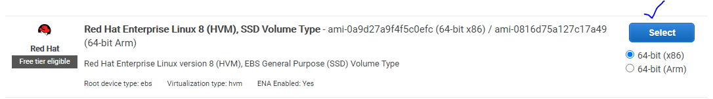
Step 2: Choose an Instance Type
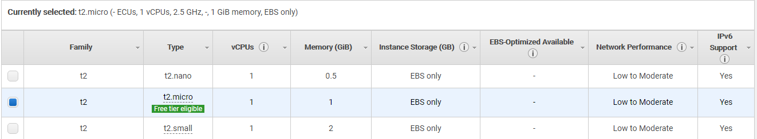

Step 3 – Configure instance details
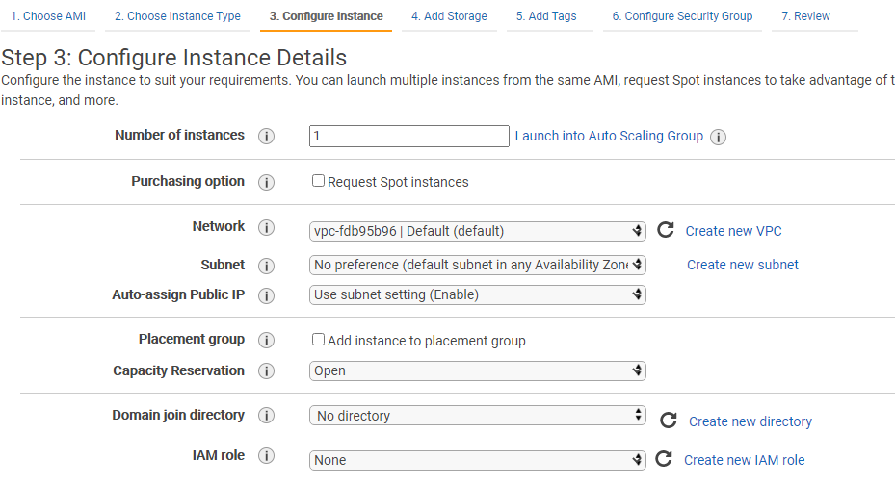
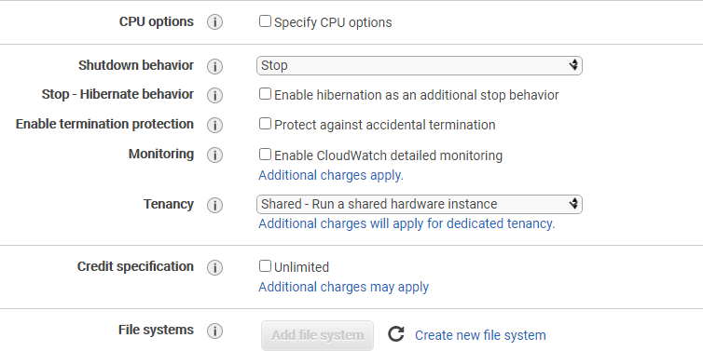

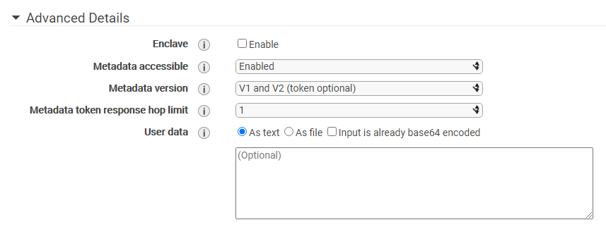
Step 4 – Add storage
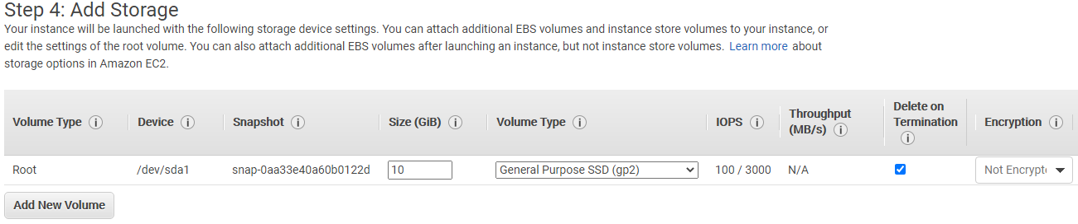
Step 5 – Add tags
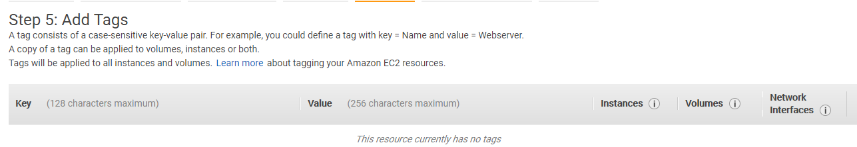
Step 6 – Add Security rules

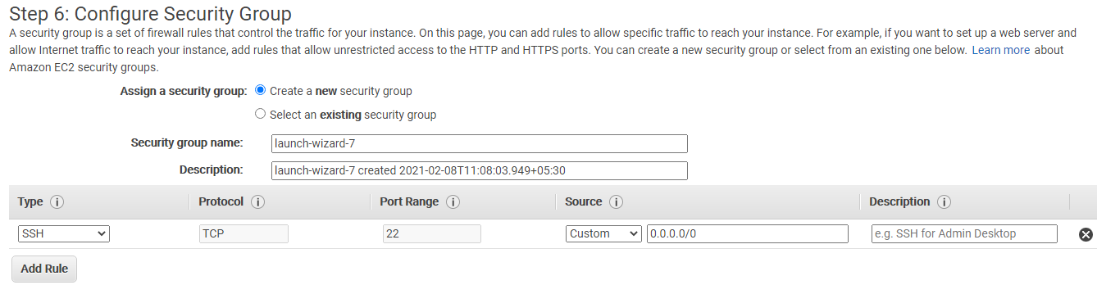
Step 7 – Review and Lunch
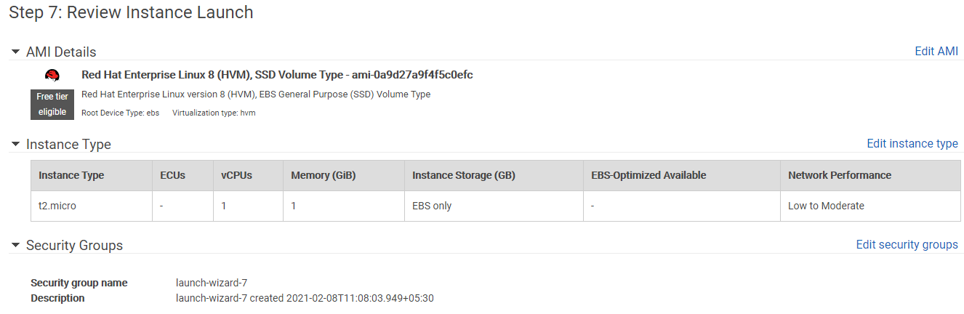
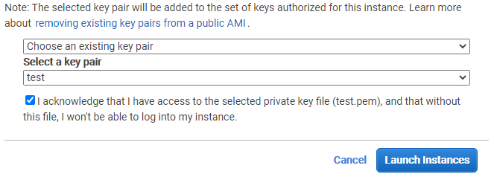
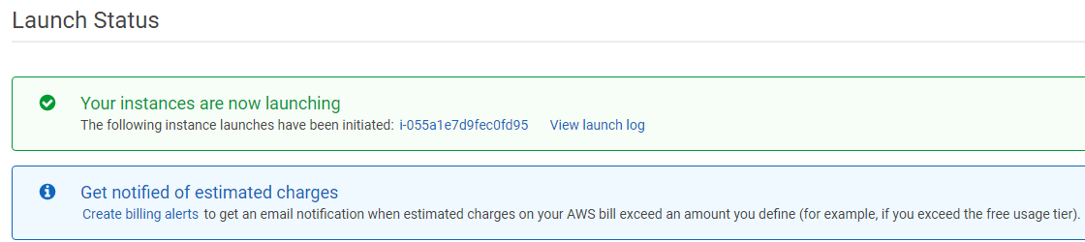

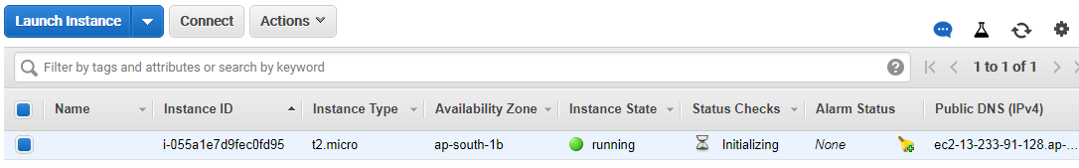
Now you can login to the EC2 instance using public IP through SSH
